Part 1
- Why is it incorrect to say iron is heavier than wood?

- Water has a density of 1000 kg/m³. A piece of rubber has a density of 1024 kg/m³. Explain what would happen if the rubber was put in a pool of water?

- This “ready-mix” concrete waggon contains 9600 kg of concrete. If the density of the concrete is 2400 kg/m³, what volume of concrete does the waggon contain?
- a. A sheet of insulating foam measures 3 m x 1 m x 0.08 m. It has a mass of 9.6 kg. Calculate the density of the insulating foam.

b. High density foam is made of the same material and can be used to give better insulation for the same thickness of foam. Describe how the arrangement of particles would differ in these two types of foam (you may draw diagrams to help your answer).

- When copper metal is heated to 1100 ºC it melts.

a. Is this a chemical or physical change? Explain your answer.

b. What will happen to the mass of the sample of copper after it has melted? Explain your answer.

- Explain the difference between a physical and a chemical change.

- Name the changes in state given in the diagram by the arrows 1 to 6.
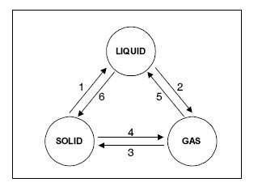

- If you wanted to find the density of a brass key, you first need to measure its volume. Describe how to determine the volume of a brass key.

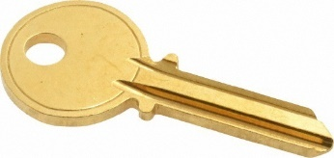
Part 2
- Define internal energy?
- Which of the following will change the internal energy of a stone?
    - Lifting it to the top of a building
    - Heating it
    - Firing it from a catapult

- Water and the chemical isooctane both boil at 100 ºC. When the same amount of each substance is placed on a heater, the isooctane boils first. Explain why this happens.

- A hot stone is placed into a glass of water containing 200 g of cold water. If the stone transfers 25 200 J of energy to the water, what will the temperature rise of the water be?
specific heat capacity of water = 4200 J/kg ºC ∆𝑸 =𝒎 × 𝒄 × ∆𝜽
- What is latent heat?

- Explain the difference between latent heat of fusion and latent heat of vaporisation.

- A boiler is being used to heat water. The graph shows the temperature of the water every 5 minutes.
  - What state is the water in between points Q and R?

  - At which point does the water begin to boil?

  - What state is the water in at 110 ºC?

- Candle wax has a latent heat of fusion of 200 000 J/kg. If the candle is at its melting temperature, how much heat energy is needed to melt a 250 g candle?
Q = m x L
- What happens to the temperature of a gas if the average kinetic energy of the particles of the gas increases?

- The sealed gas syringe is filled with air. Explain what will happen to the syringe if the air inside is gently heated.
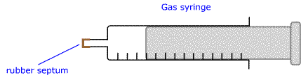

- As a weather balloon rises high in the atmosphere its volume increases. Explain why this happens.

- A cylinder of oxygen is left in the sunshine for an hour.
  - Explain what will happen to the oxygen molecules in the cylinder as they warm up.

  - Explain why these heated molecules cause a greater pressure inside the cylinder.
- When air is blown into a balloon, it expands equally in all directions. The best explanation for this is:
  - The gas molecules in the balloon are expanding
  - Internal air pressure acts at right angles to the balloon surface.
  - As more air is blown in, the temperature increases causing the balloon to expand.

- Container A is filled with a gas represented by the dots. The container size is increased but the mass of gas remains the same.

Container A Container B
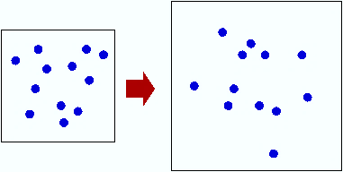

  - Explain, using the particle model, why the pressure will be less inside container B.

  - Container A has a volume of 2 m³ and a pressure of 100 000 Pa. If the expanded container has a volume of 5 m³, what will the pressure be in container B?

